9 Twex Architecture

**9.1 Systems Architecture**

Twex aims to be a crowdlending market application based on top of Ethereum protocol achieves this goal by utilizing the innovative TAG investment technologies advancing their features with new solutions based on smart contract, ERC20 Token, Hardware wallet and oracles for scalable applications.

**9.1.1 Core Components**

The Twex core components consist mainly of using innovative technologies:

1. Twex is a decentralized crowd lending platform allowing lenders split their investment and trade both part of it through smart contracts which represents Capital repayment and Interest Payment.
2. Hardware wallet allow to secure the investment by using lastest generation of authentication algorithm for facial and thumbprint recognition. Moreover, a smartcard will be implemented to store private keys and prevent any theft of customer’s data keys. Furthermore, the Twex platform will be fully compatible with external wallet like [MyEtherWallet](https://www.myetherwallet.com/) and [Metamask](https://metamask.io/).
3. Ethereum allows to run smart contracts embedded code in a decentralize way, creation of your own asset with ERC20 Token standard, making transfer and settlement of transactions without central authority.

**9.2 Smart Contract Architecture**

The Twex smart contract design follows a very modular contract structure making it easy to split functionalities to upgrade or reuse parts. The current implementation consists of over two main smart contracts describing all the process for investment, payments, period, capital and reimbursement between stakeholders. All of them will be written in Solidity Language.

During the investment process each investor will have the choice of investing an amount of TWEX Token in various projects and companies listed on Twex platform “Portfolio Companies”.

Each such investment will entitle the TWEX Token holder to two Smart Contracts issued by each of the companies receiving their TWEX Tokens as described below:

Smart Contract Interest

* Company Owner [address]
* Lending Period
* Total lending amount received [balanceof]
* Interest payment conditions [required]
* Transfert interest to beneficiaries [TransfertFrom]
* Notification interest payment [event]
* Formula interest [SafeMath]
* List of beneficiaries [mapping]
* Gross sales [oraclize]

Smart Contract Capital

* Company Owner [address]
* Total Capital opened [constant]
* Total Capital received [balanceof]
* Reimbursement benificiaries conditions [required]
* Transfert Reimbursement [TransfertFrom]
* Notification reimbursement [event]
* List of beneficiaries [mapping]

Smart Contract Holder Interest

* Beneficiary owner [address]
* Souscription date [block.time]
* Initial Investment [balanceof]
* Interest income [balanceof]

Smart Contract Holder Capital

* Beneficiary [address]
* Capital invested [balanceof]
* Reimbursement [balanceof]
* Souscription date [block.time]
* Holding period[block.time]

Smart Contract Holder Interest (n + 1)

* Benificiary owner [address]
* Souscription date [block.time]
* Initial Investment [balanceof]
* Interest income[balanceof]

Smart Contract Holder Capital – n +1

* Benificiary owner [address]
* Capital invested [balanceof]
* Reimbursement [balanceof]
* Souscription date [block.time]
* Holding period[block.time]

The Smart Contracts are the proof of their holders’ role as lender and to their inherent rights to payback of capital and interest from the company following implemented conditions of each Smart Contract issuer.

The TWEX Tokens are the proof of investment in the TWEX Ecosystem and provide to their holders a right to receive a percentage of TWEX Token held of all amounts paid by companies that received the initial funding raised for their projects through a smart contract capital.

Moreover, each of listed companies are obligated to pay 1.5 % of their gross sales outcome with the following repartition:

* 0.5% to Twex Ltd as fees to use the Twex platform services
* 1 % to Twex Token Holders will be deposited in escrow and distributed according to following formula to TWEX Holders: “1 % of Gross Sales collected X Number of TWEX Tokens held / 500,000,000 Tokens”

Please Provide an example

**Investment process**

**9.3 Oracle:**

An oracle is an agent that finds and verifies real-world occurrences and submits external information/event (price, weather, localization …) to smart contracts. In this way, contracts can interact with the off-chain world.

During the creation of the smart contract investment and capital some external events depending on some specifics conditions (delisting of the company, gross sales amount and so forth) will interact with the Blockchain for payment interest or capital pay back.

The Twex platform is oracle agnostic, any oracle solution that will be developed on Ethereum could be used by Twex.

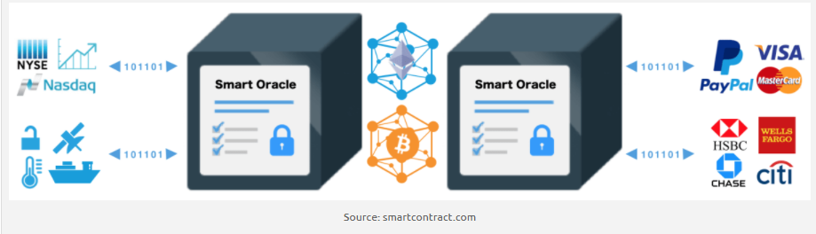

**9.3.1 Types of oracles**

There are different types of oracles on the market and each choice to use of them will depend on the cost, security and availability of the data service provider. Sometimes it will just be fine to rely on a single data provider because he might have a responsibility about the integrity of the provided data and a single source of truth. Moreover, more and more institutions are looking into

making their data smart contract compatible to share it in a distributed way.

**Software Oracles:**

Some oracles handle online information provided by company websites for example prices of commodities, goods or the conversion rate of cryptocurrency (Kraken.com) etc. The software oracle extracts the needed information and pushes it into the smart contract.

**Hardware Oracles**

Some smart contracts need information directly from the physical world, for example, a wolf crossing a barrier where movement sensors must detect the animal and send the data to a smart contract for executing actions to prevent sheep attack.

The [Oraclize](http://www.oraclize.it/) solution proposes a two-step solution to the risks, by providing cryptographic evidence of the sensor’s readings and anti-tampering mechanisms rendering the device inoperable in the case of a breach by a storm event for example.

**Consensus Based Oracles**

A decentralized contract that requires trusting a single outside data source could be considerate as a bit of a contradiction. Smart oracles take the concept of oracles a step further by placing the untrusted code execution in the oracles’ hands. This can be mitigated by having multiple independent oracles respond to the same queries to form a consensus.

For example, some prediction markets like Augur and Gnosis rely heavily on oracles to confirm future outcomes. Using only one source of information could be risky and unreliable. For better security, a combination of different oracles could be used, where for example 2 out of 3 oracles could determine the outcome of an event.